**Fur Ball 2025 – Aristocats**

|  |  |
| --- | --- |
| **Position** | Auction / Décor Set Up |
| **Date & Time** | Friday, May 9th, 2025 10:00 a.m.-2:00 p.m. |
| **Location** | Double Tree by Hilton, Banquet Entrance  1775 E Cheyenne Mountain Blvd COS, CO 80906 |
| **Dress code** | N/A |
| **Point Person** | Kelsey Moore and Grace Houston |
| **Requirements** | Best for those with an eye for and an interest in design |

**Thank you for volunteering to help with Auction/Decor Set Up!**

Decorate! Decorate! Decorate! Help with auction item layout, placing items in a way that is pleasing to the eye while following the provided guidelines about specific placements. This will include setting bottles of wine up, rearranging baskets to make them aesthetically pleasing, etc. Tables will be pre-assigned with the approximate items that will be featured on the table. You may move larger items into a different order if they do not fit chronologically (but ensure items remain close in order). If items don't fit on the tables provided ask a point person for help. You may also set the appropriately numbered (pre-labeled) paper bag, in an upright position, beneath the table, as near as possible to the corresponding auction item.

If time allows, prepare registration and volunteer areas, assist with photobooth props, place tablecloths/décor on cocktail tables, and other duties if needed. Please plan to arrive on time and stay for the entire shift.

Example without items to display:

* Please ensure all Plexi info pages are readable and staggered diagonally from each other.
* Plexis should not be directly in front of each other.
  + Example: _ -- _ -- _ -- _ -- _ --

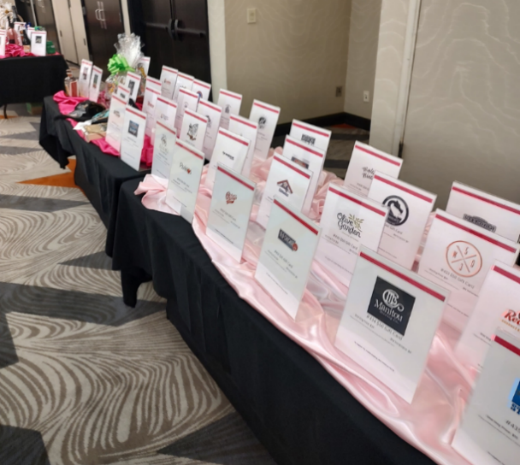

Example with liquor bottles:

* Please ensure that all labels are facing out and are not obscured by other bottles or Plexi info pages
* Packages with 2+ bottles should be set at an angle; angled line for two bottles, △ for three bottles (point of triangle facing front), ⟡ for four bottles, etc.
* If time permits, wipe down bottles with provided microfiber cloth.

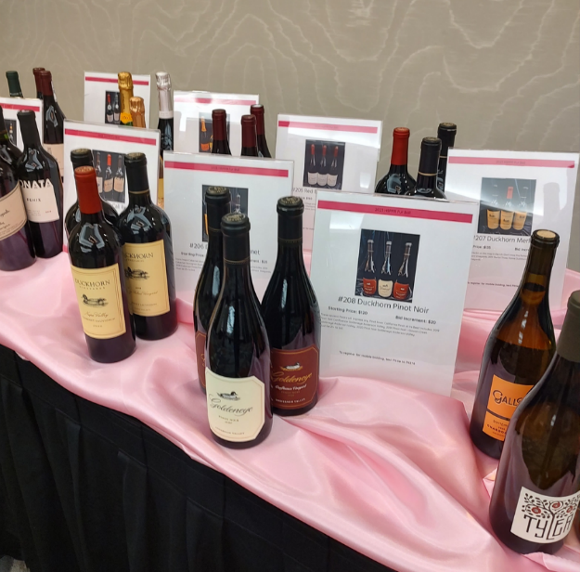

Example with Items:

* If the basket is wrapped in clear cellophane, please do *not* deconstruct.
* If the basket is **not** wrapped in cellophane, use your best judgement. Baskets can be taken apart and stored under the table if the items included will display better. If you’re able to get the items to display nicely in their carrying container, feel free to keep them in the basket.

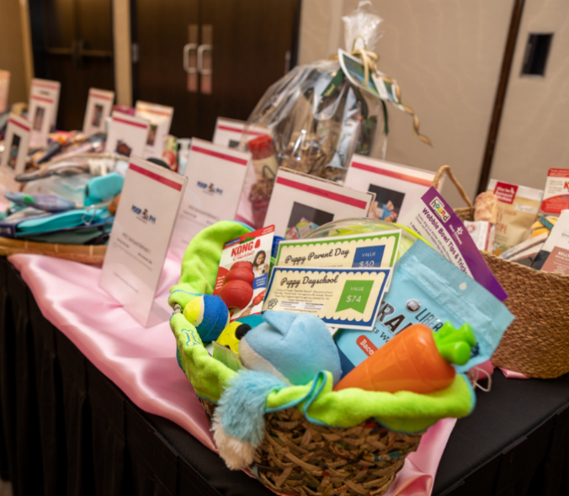

* + Please see Point Person for printed auction display example sheets and any other questions throughout the process.

*Light snacks and beverages will be provided during your shift. This shift is during lunch, if you’d like to bring a heavier snack, there will be time for a 30-minute break, if needed.*